HOW TO VIEW YOUR BILL
- Log into your student account.
- Go to “Students” Tab:
This will bring you to the Student home page:
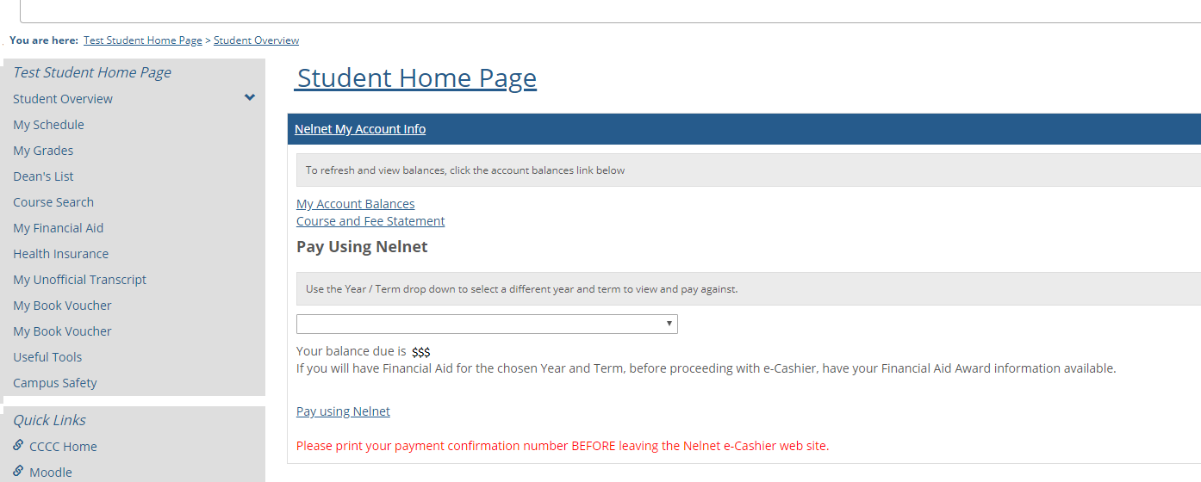
- Click on “My Account Balances”:
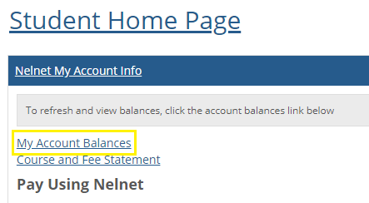
Your account balance will be reflected as several line items:
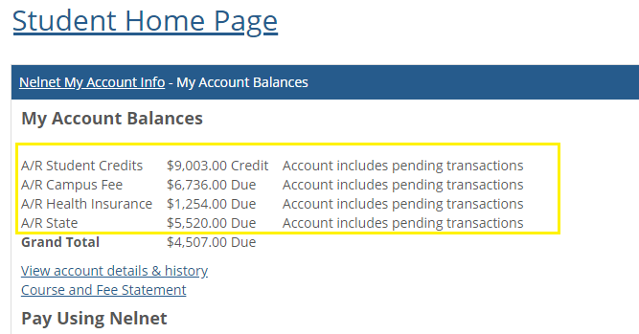
- “A/R Student Credits” reflects the total of all credits on your account, such as financial aid, any received payments, any credits adjustments to tuition and fees. This is negative/ “-“ balance on your account.
- “A/R Campus Fee” reflects the total charge for student fees for course registrations.
- “A/R Health Insurance”-you will only see this if you are registered for 9 credit hours or more. If you do have a Health insurance charge, but also have a health insurance coverage, you would want to wave it by going to www.gallagherstudent.com/cccc .
- “A/R State” reflects the total charge for tuition portion of the courses you are registered for.

HOW TO PAY YOUR BILL
- Log into your student account.
- Go to “Students” Tab:
This will bring you to the Student home page:
- In the drop down select the term you are paying/setting up payment plan:
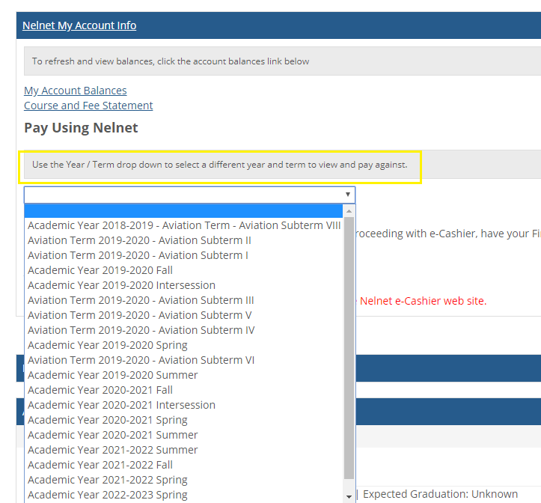

You will the balance due for the selected term right under the window. You will see the detailed balance by line item on your student account:
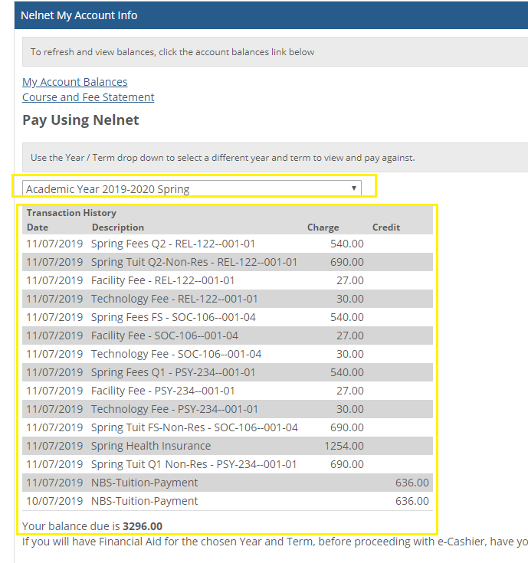
- Click on “Pay using Nelnet”:
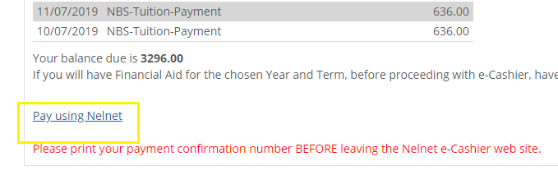

You will be directed to Nelnet website (it takes a few seconds for the page to load). On this page you will be given options to either make a payment (in full or partial), or to setup a payment plan:
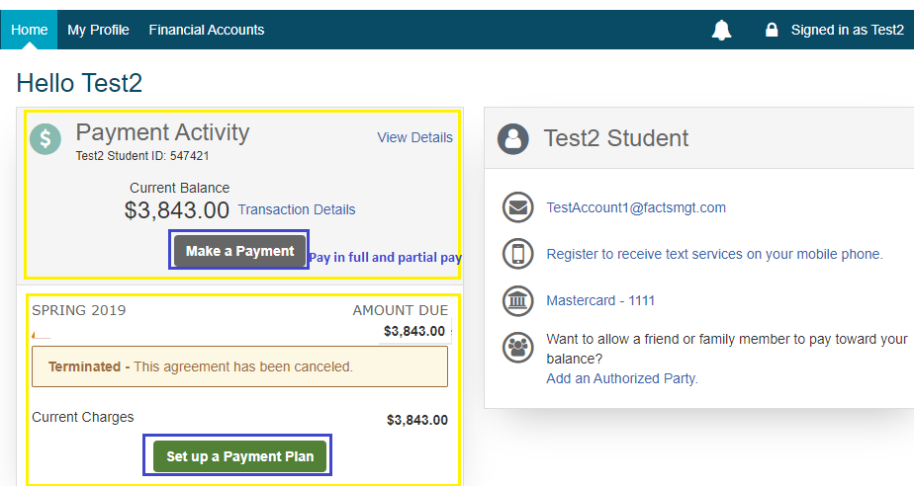

There is also an option on this page to add an authorized party, which can be used when you would like to have a friend or a family member to pay towards your balance:
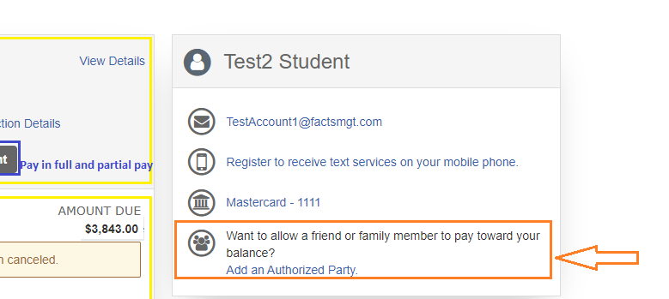

HOW TO WAIVE YOUR HEALTH INSURANCE
Under the Massachusetts Mandatory Health Insurance Law, each college must require all students carrying nine credits or more in the Day or DCE Divisions to participate in the student health insurance program or in a health insurance program with comparable coverage. The premium charge for Cape Cod Community College Health Insurance Plan will appear on your bill.
Students who would like to waive coverage need to complete the online waiver form at www.gallagherstudent.com. A complete brochure is available from this link as well as the waiver form.
To get to the link though the Student page.
- Log into your student account.
- Go to “Students” Tab:
This will bring you to the Student home page:
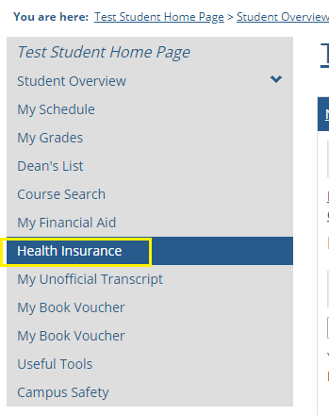
This will bring you to the necessary link:
To wave insurance, click on “Student Wave” and follow the steps provided by Gallagher:

